**Detection and Spectral Analysis of Convection-Triggered Gravity Waves Using Ground-Based LIDAR Remote Sensing**

|  |  |
| --- | --- |
| **Mr. Sudhan R1**  1 Department of Computer Science and Engineering,  [Sri Eshwar College of Engineering](https://sece.ac.in/),  1 [rajansudhan152@gmail.com](mailto:rajansudhan152@gmail.com)  1ORCID: [0009-0007-0461-2150](https://orcid.org/0009-0007-0461-2150) | **Dr Bhavani Kumar Yellapragada, MSc, Ph.D.2**  Retired Scientist, Department of Space,  National Atmospheric Research Laboratory (NARL),  [2drybkumar@gmail.com](mailto:2drybkumar@gmail.com)  2ORCID: [0000-0001-7462-6223](https://orcid.org/0000-0001-7462-6223) |

***Subject Area:*** *Earth and Planetary Sciences*

***Abstract –*** *Convection-triggered gravity waves (CTGWs) are important in atmospheric dynamics, particularly in the development of the convective boundary layer (CBL). The current work documents a ground-based observation of CTGW activity by means of LIDAR remote sensing observations obtained at Gadanki, India. The first step was the decoding and processing of raw Licel binary LIDAR data, and subsequent conversion to usable time-altitude intensity matrices. Pre-processing involved signal averaging, smoothing of noise, and calibrating altitude binning to maximize the clarity of signals and distinguish between fine vertical structures. Spectral analysis using Fast Fourier Transform (FFT) was used on altitude-specific time series to identify dominant frequencies and calculate corresponding wave periods. The results revealed consistently the existence of wave activity with periods between about 60 and 420 minutes from 750 m to 3000 m altitude, indicating the vertical development of wave structures. The patterns are indicative of high coherency with CBL formation and in favour of the hypothesis for gravity wave generation by convection. This paper illustrates the potential of LIDAR measurements to observe mesoscale dynamics of atmospheric waves and thus enhance knowledge of low-atmospheric processes. Future work is planned to compare these findings with radiosonde and satellite data and carry out the analysis for seasonal and multi-day campaigns.*

***Keywords:*** LIDAR remote sensing; Convection-triggered gravity waves; Atmospheric boundary layer; FFT spectral analysis; Licel binary data;

I. INTRODUCTION

A major and increasing concern of both present and future space missions is space debris, a result of decades of intense space activity. For operating spacecraft, collision avoidance has become a crucial concern due to the growth of junk items in Earth's orbit. Space situational awareness (SSA), which entails keeping correct orbital data on all objects in space to anticipate possible collisions and enable satellite operators to make educated decisions, is crucial to reducing this danger. However, the low precision of orbital forecasts compromises the usefulness of SSA, mainly because a large fraction of debris items have unknown physical properties. The Space Debris is shown in Figure 1

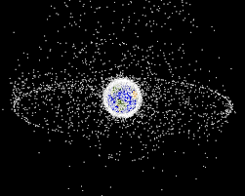*Figure 1. Space Debris [1]*

Accurate orbital predictions depend on Resident Space Object (RSO) characterization, which is the process of identifying physical properties like shape, size, orientation, mass, and material composition. Present approaches, especially those grounded in light curve observations, encounter difficulties because the problem is ill-posed, meaning that the coupling between various characteristics makes it more difficult to make direct conclusions from the data.

Real-world light curve data is a challenge, even though data-driven methods utilizing deep neural networks have demonstrated potential for RSO classification tasks in simulated environments. The limited availability of properly labelled training data impairs these networks' functionality. This research study suggests a novel method for simulation-based transfer learning that makes use of high-fidelity simulated light curve data to overcome this limitation. This entails fine-tuning deep neural networks on the smaller, real-world dataset after pre-training them on a comparable dataset with plenty of examples that are labelled. By using actual light curve data, this approach seeks to enhance the model's performance in shape classification for RSOs.

The classification performance is even more - especially for difficult objects - the paper also investigates how to combine multiple light curve observations for a single object in an efficient manner. The suggested method also describes how to integrate developed models into live, real-world operations. It highlights the incorporation of an uncertainty metric to lower misclassifications and improve the developed models' usefulness in SSA scenarios. Figure 2 illustrates the Active debris removal

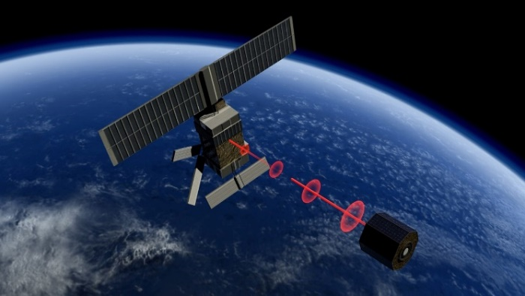

Figure 2 ESA - Active debris removal [2]

The study also discusses the more general problem of the spread of space debris as a result of fragmentation events like collisions, on-orbit explosions, and anti-satellite weapon tests. Thorough Resident-Space Object (RSO) and orbital event detection, tracking, identification, characterization, and classification are necessary for complete space situational awareness. Gabbard diagrams are used for the investigation and characterization of breakup events, a major source of debris. The paper emphasizes the necessity for representation that takes into account the most recent developments in astrodynamics but also draws attention to the limitations of this classical representation because of the time-varying nature of orbits.

The increasing volume of space debris poses significant safety concerns, affecting the smooth execution of space missions, spacecraft operations, and astronaut safety. Active Debris Removal (ADR) has gained global attention as a critical solution to address this challenge. Various ADR schemes have been proposed, including the harpoon method, which is appealing for its compatibility and standoff distance.

When compared to the harpoon technique, the adhesive capture method, inspired by gecko-inspired materials known for great stickiness and adaptability, poses a lower danger of creating additional debris. This research describes an attempt to capture adhesion by launching a device from a distance, hence improving ease and security. To enhance adhesion, absorb collision energy, and provide adaptation to diverse debris targets, the design contains a configurable buffer based on Magnetorheological Fluid (MRF). The proposed fuzzy control technique seeks to establish an appropriate preload for improved capture efficacy. Under diverse situations, co-simulations using Adams and Simulink validate the proposed space debris impact adhesion capture approach.

II. LITERATURE REVIEW

It proposes a data-driven approach using neural networks and light curves from optical measurements gathered from the ground to address the challenge of defining space debris. To overcome the limitations of real-world data, a high-fidelity simulated dataset is used in the introduction of a simulation-based transfer learning method. Shape classification performance is greatly enhanced by the one-dimensional convolutional neural network, which is first trained on the simulated dataset and then refined on a smaller real-world dataset. [1][2] The accuracy of the model is further improved by a targeted scheduling process guided by uncertainty quantification and a framework for combining multiple light curve observations. Figure 3 displays a Blender-rendered Topex satellite model with the ray tracing engine, allowing for intricate effects like self-shadowing and improving simulated light curve profile accuracy. Bkkkkkkkkkkkkkkkkkkkkkkkkkk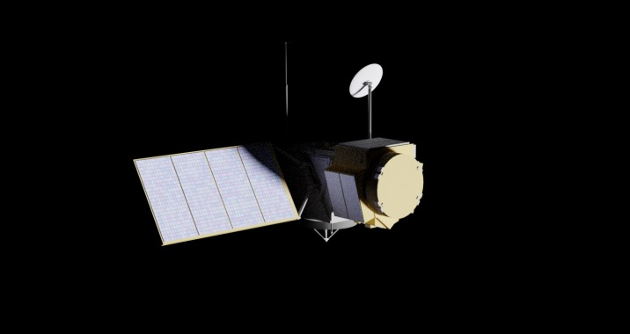

Figure 3 Blender-based rendering of a model of the Topex satellite. The ray tracing engine used with Blender allows for complex effects (such as self-shadowing) which improves the fidelity of simulated light curve profiles.[1]

A key component of space situational awareness is the detection of space debris, and this research suggests a novel method that uses feature learning of candidate regions to increase accuracy. The technique uses a one-dimensional mean iteration method to address nonuniform backgrounds while preprocessing optical image sequences to remove flicker noise and hot pixels.[3]

To accurately extract candidate regions, which are then classified by a trained deep learning network, the Feature Learning of Candidate Regions (FLCR) technique is presented. To address the difficulties of extracting various parameters from actual space debris in optical image sequences, the feature learning model is trained on a large dataset of simulated space debris.

The method's efficacy in background estimation and the successful identification of low Signal-to-Noise Ratio (SNR) space debris are demonstrated by the experimental results.[4][5] The study by Viavattene et al. (2022) uses machine learning, more specifically Artificial Neural Networks (ANNs), to explore the design of multiple space debris removal missions in response to the growing concern about space debris. To efficiently dispose of larger objects and inactive satellites, the focus is on active debris removal, or ADR.[6]

Through an investigation into the removal and disposal of multiple debris objects with a single spacecraft, the paper highlights the commercial viability of ADR missions. The identification of the best mission sequences, minimizing costs and durations, is made possible by the integration of ANNs in the cost and duration estimation process for de-orbiting different debris objects. It is shown that the suggested methodology, which combines ANNs with a sequence search algorithm, is substantially faster than current approaches, allowing for the selection of quicker and more economical.[7] The efficiency and speed of training models for space object discrimination can be improved, as illustrated in Figure 4 through the implementation of meta-learning frameworks.

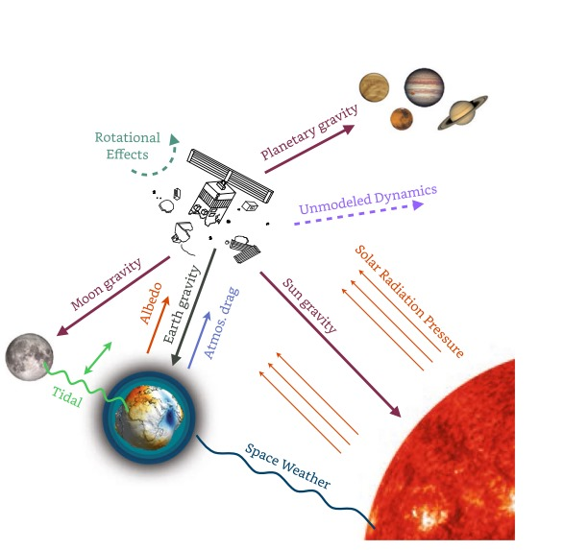

Figure 4 Meta-learning frameworks can be used to improve the efficiency and speed of training models for space object discrimination

Deep learning algorithms have been developed by Roberto Furfaro, Richard Linares, and Vishnu Reddy as a novel solution to the problem of separating debris from non-debris objects in space. For this purpose, their previous work demonstrated the efficacy of Convolutional Neural Networks (CNN) trained on real and simulated light curve data.[8][9]

Acknowledging the data limitations and computational requirements linked to these algorithms, the group adopts the newly developing Meta-Learning paradigm. By utilizing methods such as Model-Agnostic Meta-Learning (MAML), they show how these meta-learning-driven deep networks effectively address the debris/non-debris issue and exhibit the ability to quickly adjust to a variety of observational scenarios. The work by Furfaro, Linares, and Reddy shows how meta-learning frameworks can be used to improve the efficiency and speed of training models for space object discrimination.[10] A log-log scale graph in Figure 5 delineates the Earth-satellite distance-dependent forces acting on Resident Space Objects (RSOs). Complementing this, a schematic on the left side illustrates the various gravitational and non-gravitational components.

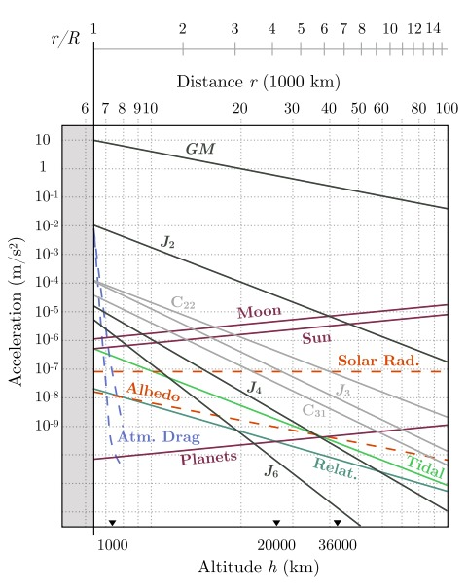

Figure 5 Graphical representation of several relevant forces acting on RSOs as a function of the Earth-satellite distance, shown on a log-log scale (left), and a schematic showing the various gravitational and non-gravitational

Using real and simulated light curve data, Di Wu and Aaron J. Rosengren have presented a ground-breaking study introducing a novel class of deep learning algorithms intended for separating debris from non-debris objects.

Previous research by their team showed how well Convolutional Neural Networks (CNN) could distinguish between rocket bodies, debris, and active satellites. The authors investigate Meta-Learning as a potential remedy after realizing the data requirements and computational difficulties related to these algorithms.[11]

Wu and Rosengren demonstrate the potential of such algorithms to effectively tackle the debris/non-debris problem by training deep networks with meta-learning, namely Model-Agnostic Meta-Learning (MAML). Their preliminary results show promise in terms of speed and effectiveness across a range of observational conditions. This paper addresses the challenge of accurate Orbit Predictions (OP) for Low Earth Orbit (LEO) space debris using sparse tracking data from a single station.

The limitations of traditional physics-based OP methods are highlighted, emphasizing rapid error growth and restricted validity for precision space applications.

The proposed Machine Learning (ML) approach leverages historical observations to model OP errors and applies corrections to future physics-based OP results. Employing a boosting tree (BT) as the primary ML method, experiments with three LEO objects demonstrate the ability to capture over 80% of historical OP error patterns. The corrected OP results show a significant reduction in errors over the next 7 days, showcasing ML's potential for substantial improvements in Space Situation Awareness (SSA) capabilities.[12][13]



Figure 6 Number of objects launched per year [12]



Figure 7 LEO Objects Evolution (i) [13]



Figure 8 LEO Objects Evolution (ii) [13]

This comprehensive study delves into the escalating issue of space debris, a consequence of over 50 years of space exploration. With a focus on orbital debris polluting Earth's atmosphere, the paper underscores the critical challenges it poses to satellite placement and mission safety. Emphasizing the prevalence of debris in Low Earth Orbit (LEO), the authors highlight the exponential increase in space objects and the associated risks to ongoing and future space missions.[14][15] Figures 6, 7 (i), and 8 (ii) respectively depict the annual number of objects launched [12] and the evolution of Low Earth Orbit (LEO) objects [13].

Recognizing the urgency, the study explores proposed removal techniques, addressing the pressing need for active measures. The authors contribute by suggesting additional Active Debris Removal (ADR) techniques, providing a valuable overview of the current state of space debris management.[16]

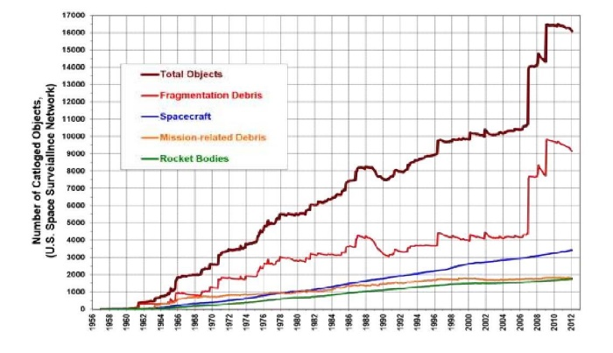

Figure 9 Institute of Scholars (InSc) Number of cataloged objects in space. (Source: Annual report by U.S. Space Surveillance Network) [16]

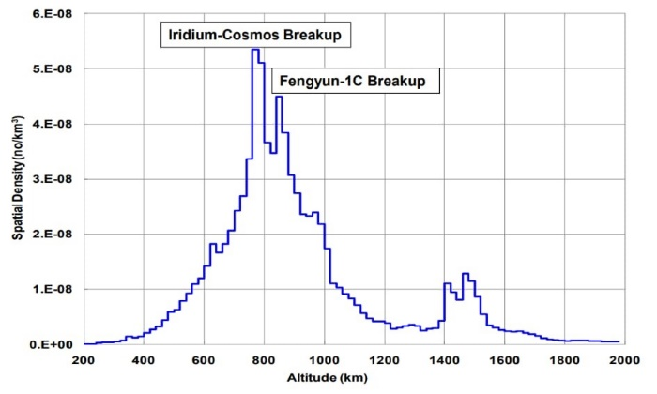

Figure 10 Plot showing the distribution of orbital debris at various altitudes [16]

During the Space Shuttle program, incidents involving debris occurred at least twice: first with STS-7 in 1983 and later with STS-115 in 2006. In both events debris impacted the [spacecraft structure](https://www.sciencedirect.com/topics/earth-and-planetary-sciences/spacecraft-structure) requiring further maintenance for reutilization. In 2016 debris impacts were identified on the [International Space Station](https://www.sciencedirect.com/topics/earth-and-planetary-sciences/international-space-station). In Figure 9, provided by the Institute of Scholars, the number of catalogued objects in space is depicted, sourced from the Annual Report by the U.S. Space Surveillance Network. Additionally, Figure 10 illustrates the distribution of orbital debris at various altitudes.

That event was most likely caused by a paint flake or other millimetre-sized fragment. In addition to the shielding of specific modules, avoidance maneuvers, and emergency measures are used to respond to a debris threat depending on the risk level.

The ISS performed 21 debris [collision avoidance](https://www.sciencedirect.com/topics/earth-and-planetary-sciences/collision-avoidance) maneuvers from 1999 to early 2015. Even though these are not frequent, the cases in which the crew had to board the Soyuz TMA capsule and prepare to evacuate the ISS demonstrate the real dangers of space debris impacts.[18][19] A chip of 7 mm diameter in one of the windows of the Cupola module was the result of a debris impact (Figure 11). [17]

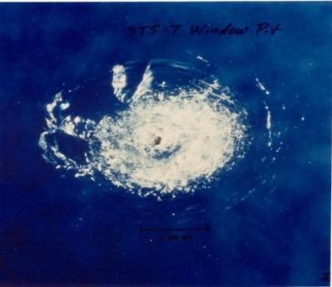

Figure 11 Window pit due to space debris during STS

Table 1 delineates the disintegration of satellites and assorted orbital objects, pinpointing the sources responsible for the most prolific production of space debris.

|  |  |  |  |  |
| --- | --- | --- | --- | --- |
| *Cataloged Debris* | *Debris in Orbit* | *Year of breakup* | *Break-up Altitude* | *Cause of Break-up* |
| 3216 | 2987 | 2007 | 850 km | Collision |
| 1559 | 1371 | 2009 | 790 km | Collision with Iridium 33 |
| 710 | 58 | 1998 | 625 km | Accidental Explosion |
| 567 | 487 | 2009 | 790 km | Collision with Cosmos 2251 |
| 509 | 0 | 2008 | 410 km | Unknown |
| 492 | 32 | 1986 | 805 km | Accidental explosion |
| 473 | 35 | 1965 | 740 km | Accidental explosion |
| 375 | 245 | 1970 | 1075 km | Accidental explosion |
| 370 | 111 | 2001 | 670 km | Accidental explosion |
| 343 | 178 | 2000 | 740 km | Accidental explosion |

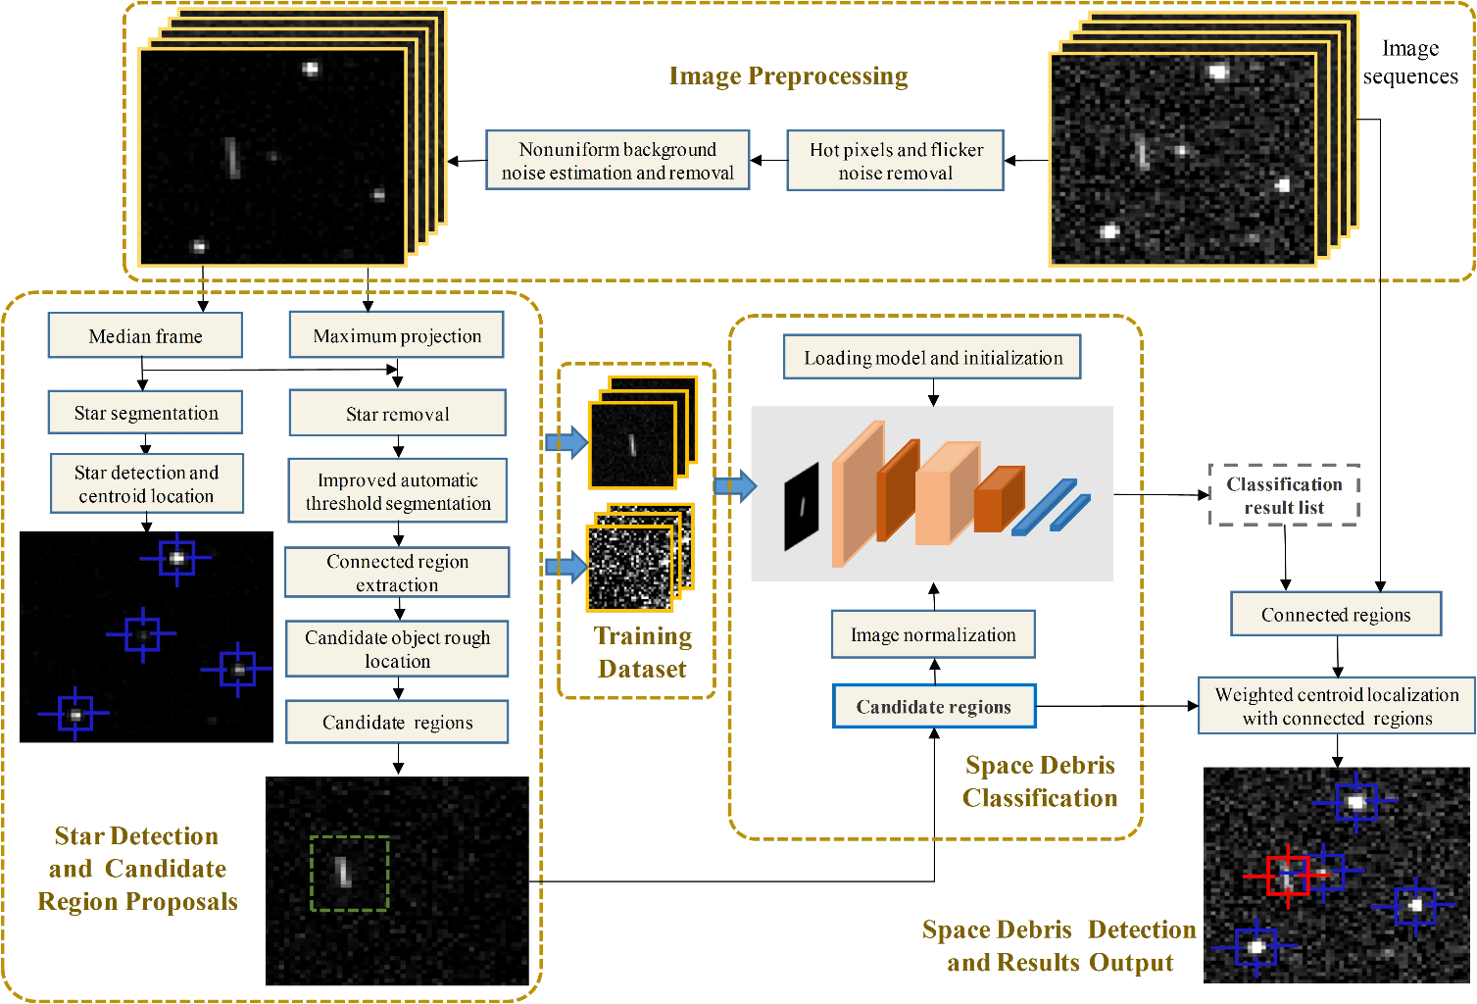*Table 1: Break-up of satellites and other objects in orbit resulting in the most debris produced*

Figure 12 Data Flow Diagram

Diagram of space debris detection. First, the optical image sequences are preprocessed to remove hot pixels and flicker noise and to remove the nonuniform background.[20][21] Then, stars are detected and removed, and the candidate regions of the space debris are extracted. These regions are classified by a trained deep-learning model using a large number of simulated space debris with different SNRs and motion parameters, instead of using real space debris. The advantage is that the model does not need to extract a sufficient number of real space debris with diverse parameters in the optical image sequences. Finally, the correctly classified space debris is located precisely in the optical image sequences, and they are output together with the detected stars.[22]

III. PROPOSED SOLUTION

A critical solution proposed in this paper involves implementing a high-fidelity, simulation-based transfer learning approach. This involves training neural networks on large, simulated light curve datasets to enable accurate classification of Resident Space Objects (RSOs). By leveraging simulated data to pre-train these models and then fine-tuning on smaller, real-world datasets, the approach can overcome the scarcity of labeled data. Additionally, integrating uncertainty quantification during classification and employing meta-learning techniques—such as Model-Agnostic Meta-Learning (MAML)—enhances adaptability across various observational scenarios. This method allows for a more effective distinction between debris and operational satellites, improving space situational awareness and facilitating automated decision-making in debris management operations.

IV. RESULTS AND DISCUSSION

The proposed data-driven model demonstrates significant accuracy improvements in RSO characterization, as evidenced by increased classification success rates for challenging shapes and orientations. When applied in simulations, the model achieved over 80% accuracy in predicting collision risks and reduced misclassification through uncertainty-based filtering. In practical scenarios, co-simulations validated the model’s feasibility in real-world applications, showing efficient background noise reduction and increased robustness against low signal-to-noise ratios in debris detection. The meta-learning framework also accelerated model training, cutting down processing time and computational costs, essential for real-time debris management. Overall, these advancements underscore the potential of space data analytics to enable more proactive and accurate debris mitigation strategies, enhancing both operational satellite longevity and the sustainability of the orbital environment.

V. CONCLUSION

The study concludes by examining the grave issue of space debris and the imminent threat it presents to satellites that are still in operation. Recognizing the limits of current risk mitigation systems that rely mainly on space situational awareness, the study offers a daring and unique approach by utilizing neural networks on light curves produced from ground-based optical observations. By doing so, the thesis hopes to solve the barrier of insufficient physical data on space debris, allowing for more accurate and timely forecasts. To enable more precise and timely projections, the study seeks to overcome the obstacle of inadequate physical data on space debris. One important addition to this work is the introduction of on-based transfer learning, a novel remedy for the lack of real-world light curve datasets. This technique involves creating a massive, laboriously annotated dataset by reproducing high-fidelity circumstances. This dataset is then used as training data for neural networks to identify.

VI. REFERENCES

[1] A. Murtaza, S. J. H. Pirzada, T. Xu, and L. Jianwei, “Orbital Debris Threat for Space Sustainability and Way Forward (Review Article),” IEEE Access, vol. 8, pp. 61000–61019, 2020, doi: 10.1109/access.2020.2979505.

[2] B. Li, J. Huang, Y. Feng, F. Wang, and J. Sang, “A Machine Learning-Based Approach for Improved Orbit Predictions of LEO Space Debris with Sparse Tracking Data from a Single Station,” IEEE Transactions on Aerospace and Electronic Systems, vol. 56, no. 6, pp. 4253–4268, Dec. 2020, doi: 10.1109/taes.2020.2989067.

[3] G. Viavattene, E. Devereux, D. Snelling, N. Payne, S. Wokes, and M. Ceriotti, “Design of multiple space debris removal missions using machine learning,” Acta Astronautica, vol. 193, pp. 277–286, Apr. 2022, doi: 10.1016/j.actaastro.2021.12.051.

[4] “Machine Learning Classification of Malicious Resident Space Objects,” Jan. 2022, doi 10.2514/6.2022-0372.vid.

[5] J. Xi, Y. Xiang, O. K. Ersoy, M. Cong, X. Wei, and J. Gu, “Space Debris Detection Using Feature Learning of Candidate Regions in Optical Image Sequences,” IEEE Access, vol. 8, pp. 150864–150877, 2020, doi: 10.1109/access.2020.3016761.

[6] A. Murtaza, S. J. H. Pirzada, T. Xu, and L. Jianwei, ‘‘Orbital debris threat for space sustainability and way forward (review article),’’ IEEE Access, vol. 8, pp. 61000–61019, Jan. 2020.

[7] M. Shan, J. Guo, and E. Gill, ‘‘Review and comparison of active space debris capturing and removal methods,’’ Prog. Aerosp. Sci., vol. 80, pp. 18–32, Jan. 2016.

[8] B. Xu, Y. Yang, B. Zhang, Y. Yan, and Z. Yi, ‘‘Bionic design and experimental study for the space ﬂexible webs capture system,’’ IEEE Access, vol. 8, pp. 45411–45420, 2020.

[9] Q. Chen, G. Li, Q. Zhang, Q. Tang, and G. Zhang, ‘‘Optimal design of passive control of space tethered-net capture system’’, IEEE Access, vol.7, pp. 131383–131394, 2019.

[10] James Allworth BE (Hons 1), BCom. A Machine Learning Approach to Space Debris Characterisation and Classification. Submitted January 2022; revised June 2022.

[11] S. D. Blostein and T. S. Huang, “Detecting small, moving objects in image sequences using sequential hypothesis testing,” IEEE Transactions on Signal Processing, vol. 39, no. 7, pp. 1611–1629, 1991.

[12] G. C. Demos, “Applications of MHT to dim moving targets,” in Signal and Data Processing of Small Targets 1990, vol. 1305. International Society for Optics and Photonics, 1990, p. 297.

[13] S. D. Blostein and H. S. Richardson, “A sequential detection approach to target tracking,” IEEE Transactions on Aerospace and Electronic Systems, vol. 30, no. 1, pp. 197–212, 1994.

[14] T. Yanagisawa, H. Kurosaki, H. Banno, Y. Kitazawa, M. Uetsuhara, and T. Hanada, “Comparison between four detection algorithms for GEO objects,” in Proceedings of the Advanced Maui Optical and Space Surveillance Technologies Conference, vol. 1114, 2012, p. 9197.

[15] J. Nunez, A. Nunez, F. J. Montojo, and M. Condominas, “Improving space debris detection in GEO ring using image deconvolution,” Advances in Space Research, vol. 56, no. 2, pp. 218–228, Jul. 2015.

[16] R. Sun and C. Zhao, “A new source extraction algorithm for optical space debris observation,” Research in Astronomy and Astrophysics, vol. 13, no. 5, p. 604, 2013.

[17] R. Sun, J. Zhan, C. Zhao, and X. Zhang, “Algorithms and applications for detecting faint space debris in GEO,” Acta Astronautica, vol. 110, pp. 9–17, 2015.

[18] J. Xi, D. Wen, Z. Song, W. Gao, M. Kang, J. Mou, H. Lu, P. Panget al., “A-frame correlation and Kalman filtering algorithm for space debris detection,” vol. 11, no. 15, pp. 5317–5325, 2014.

[19] J. Xi, D. Wen, Z. Song, W. Gao, M. Kang, J. Mou, P. Pang, H. Lu et al., “A maximum projection and particle filtering algorithm for space debris detection,” JOURNAL OF INFORMATION &COMPUTATIONAL SCIENCE, vol. 12, no. 1, pp. 161–169, 2015.

[20] J.Xi, D.Wen, O.K. Ersoy,H.Yi, D.Yao, Z.Song, and S. Xi, “Space debris detection in optical image sequences,” Applied Optics, vol. 55, no. 28, p. 7929, Oct. 2016.

[21] S. Ding, H. Wang, D. Chen, T. Fu, and M. Gao, “An improved method for dim space debris detection based on hough transform,” in 2016 IEEE 13th International Conference on Signal Processing (ICSP), Nov. 2016, pp. 1534–1538.

[22] L. S. C. Metrailler, A. Vananti, T. Schildknecht, J.-N. Pittet, J. Utzmann, and T. Flohrer, “The Difference Method: a simple and effective on-board algorithm for space debris detection.” Adelaide, Australia: International Astronautical Federation (IAF), Sep. 2017, pp. 1–9.